PRE REQUISTIES IBM CLOUD SERVICES

|  |  |
| --- | --- |
| **TEAM ID** | **PNT2022TMID53703** |
| **PROJECT NAME** | **IOT BASED SMART CROP**  **PROTECTION SYSTEM FOR AGRICULTURE** |

**STEP 1:**

Create your IBM cloud account using web mail and password using <http://ibm.com/academic/home> URL. Then sign in your username and password.

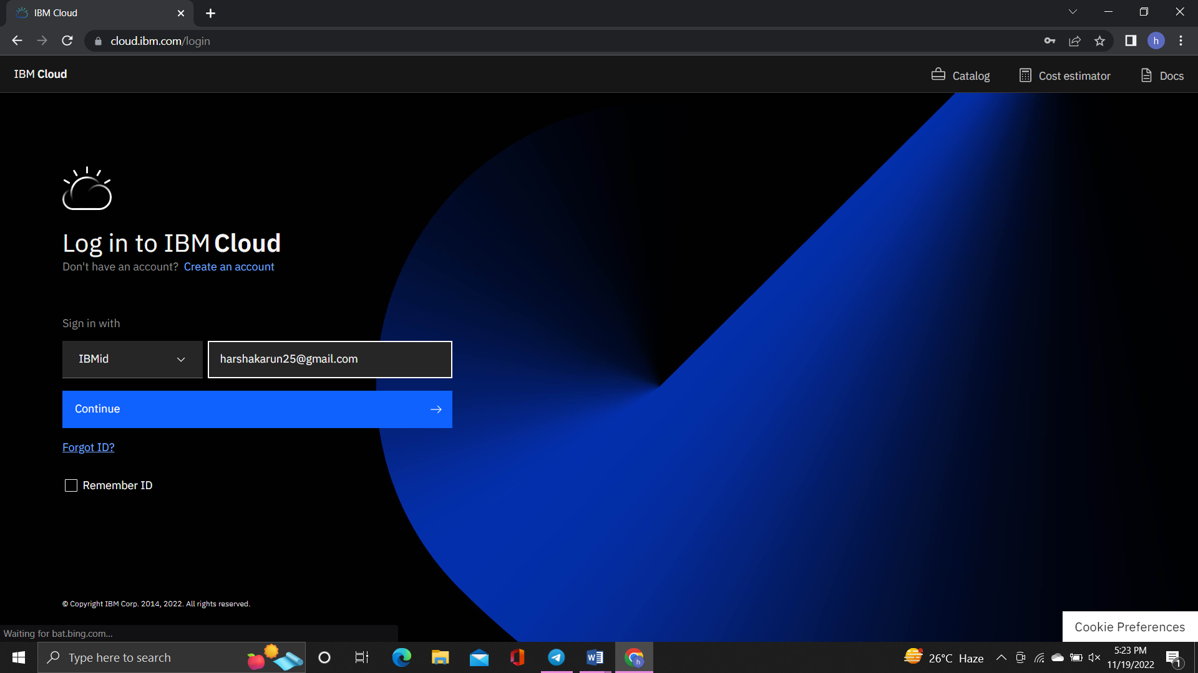

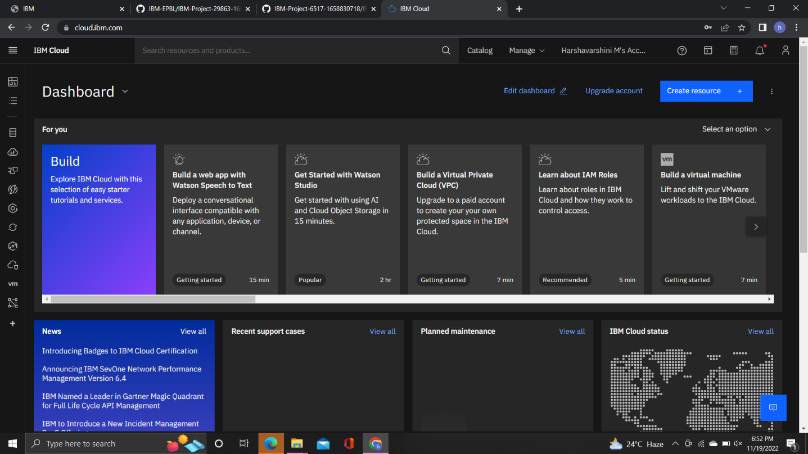

**STEP 2:**

Next search IBM IOT Watson platform. Then create IBM IOT Watson and launch it.

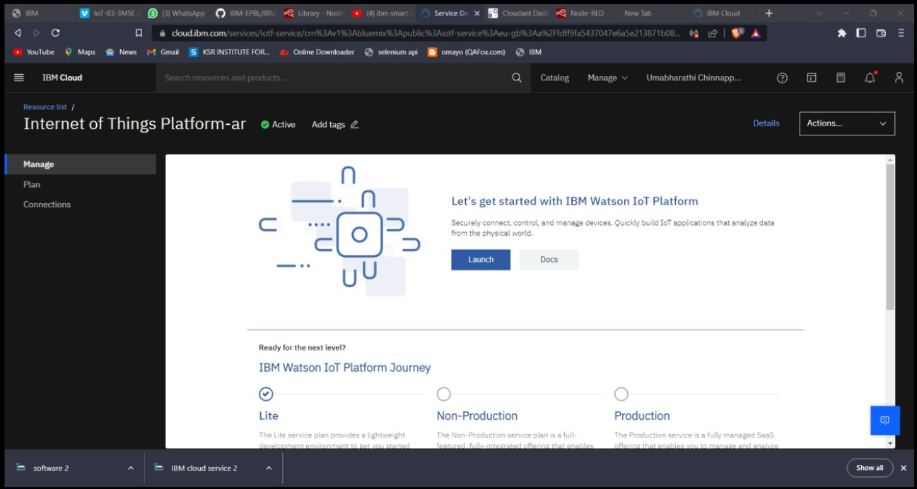

**STEP 3:**

Next search Node-Red service in search bar. Then create Node-Red account and launch Node-Red service. It shows the dashboard of Node-Red service.

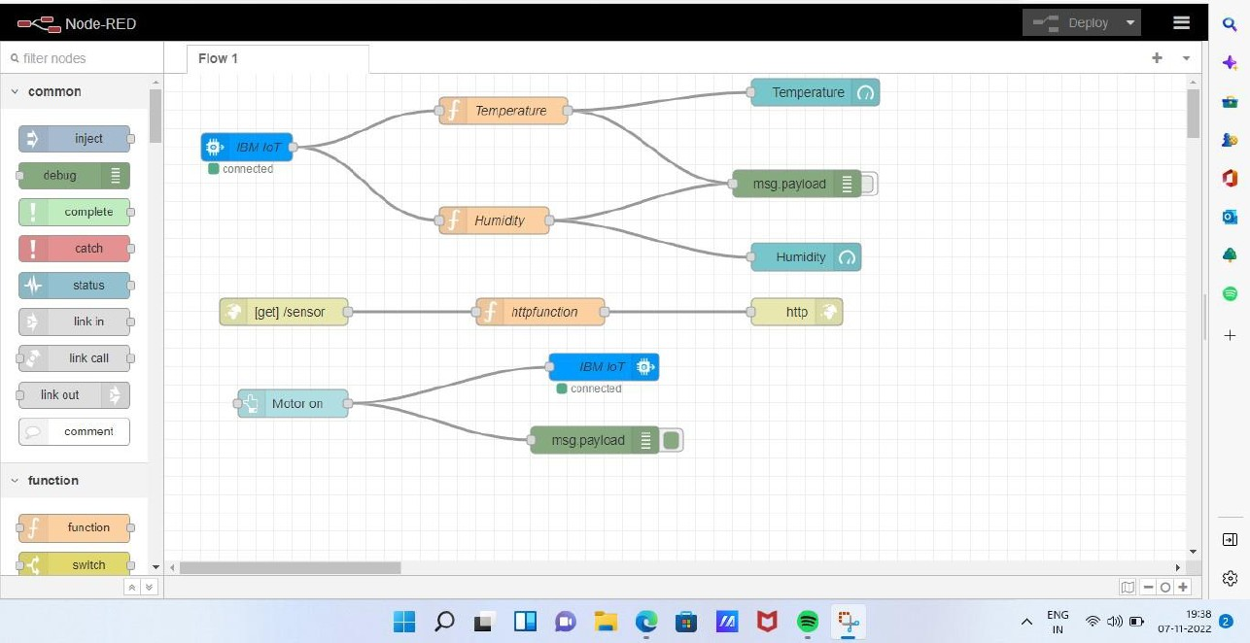

**STEP 4:**

Open node-red-yychd-2022--cloudant-1667643063389-1946 open this link.

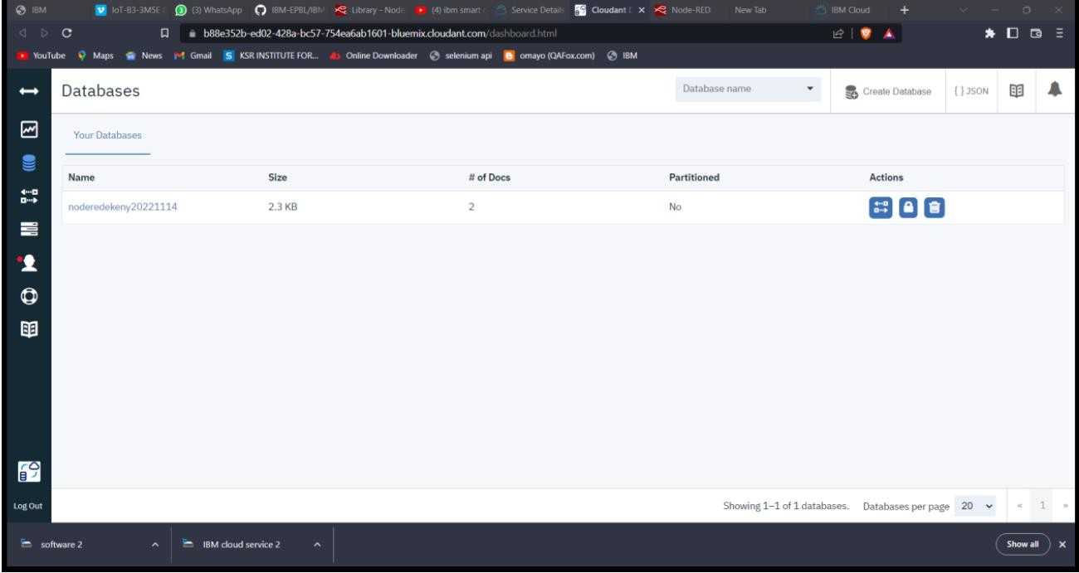

**STEP 5:**

Search object storage in search bar, then click object storage. Click create button in bottom right corner.

